# Data Visualisation Coursework 2: Tableau

### Alun Meredith & Nicola

### 29th April 2016

### 

# Design Philosophies

The main philosophy is consistency and intuitive user interactions, using a drill-down narrative with the focus on the map as an overview and the other visualisations as drilling down into different factors. Active filters are used to further this goal in as intuitive manner as possible.

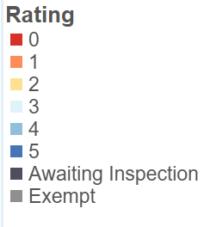The colour scheme was designed to represent the 6 ordinal rating values from a negative colour (red) representing a poor rating to a neutral colour (blue) for good rating, because a good score is the expected value. Greys were used to distinguish the non-ordinal values. **Ideally a monochrome rather than diverging scale would be used but this was found to have too low differentiability with 6 values**. A tool from colorbrewer2.org generated a colour palette to ensure that it was colour blind and printer friendly.

Figure 1 Colour Scale used throughout each visualisation (Source colorbrewer2.org)

Where possible missing and NA values are included in the visualisation. These can themselves yield important patterns and not showing them can mislead the user into confusing missing data and NAs and 0 values. However this often wasn’t possible due to lack of space and limitations with tableau.

Filtering and highlighting within charts are used with caution, we don’t want any new information gated under these as when applied in combination with the active filtering on the dashboard this can confuse users.

# Map

Using geocode data provided for each business (Longitude and Latitude) it is possible to uniquely locate each observation.

To make map points as clear as possible, along with the colour scheme mentioned above a halo effect and 80% transparency has been used. The best compromise of size and transparency considering overlap of points.

For explanatory data analysis purposes it is useful to add a filter on the possible values of the Rating Value variable. This allow us to immediately visualize specific ratings on the map seeking for possible geographical trends.

A google map view of the business was included. Adding too much detail to the core map distracts attention from the data point while this side view not only allows viewers to drill down into location information but also embed dynamic google data.

The 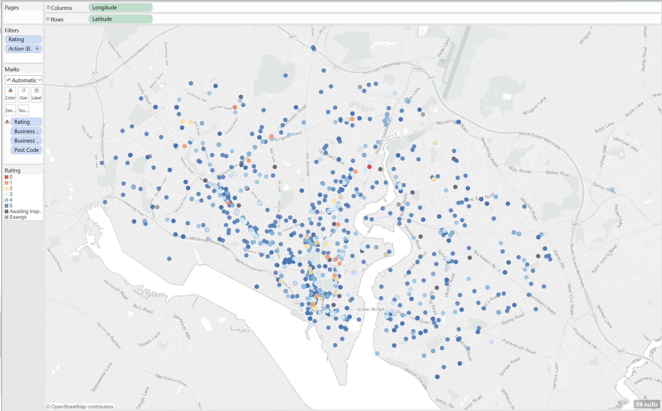

Figure 2: The tooltip of map points has been kept as briefer as possible including only Business Name and Rating Value to allow a better reading of the map.



Figure 3: Assigning the Longitude variable to the columns field and the Latitude to the rows, the software assigns a position on the map to any observation of the dataset

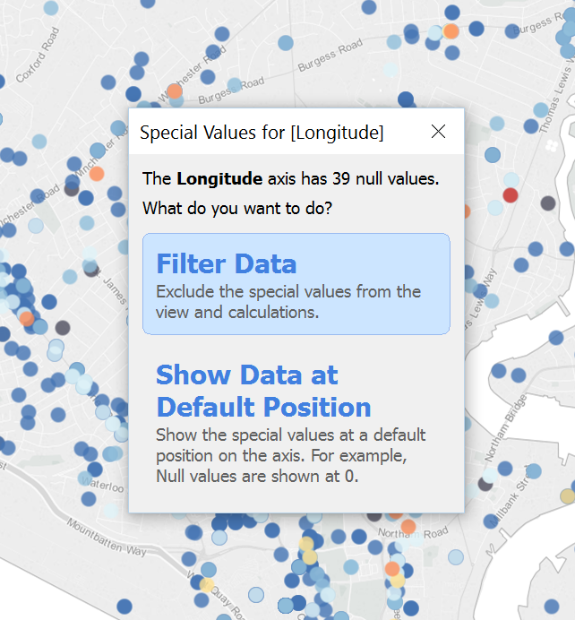

Figure 4: Data filter to exclude points for which Latitude information is missing.

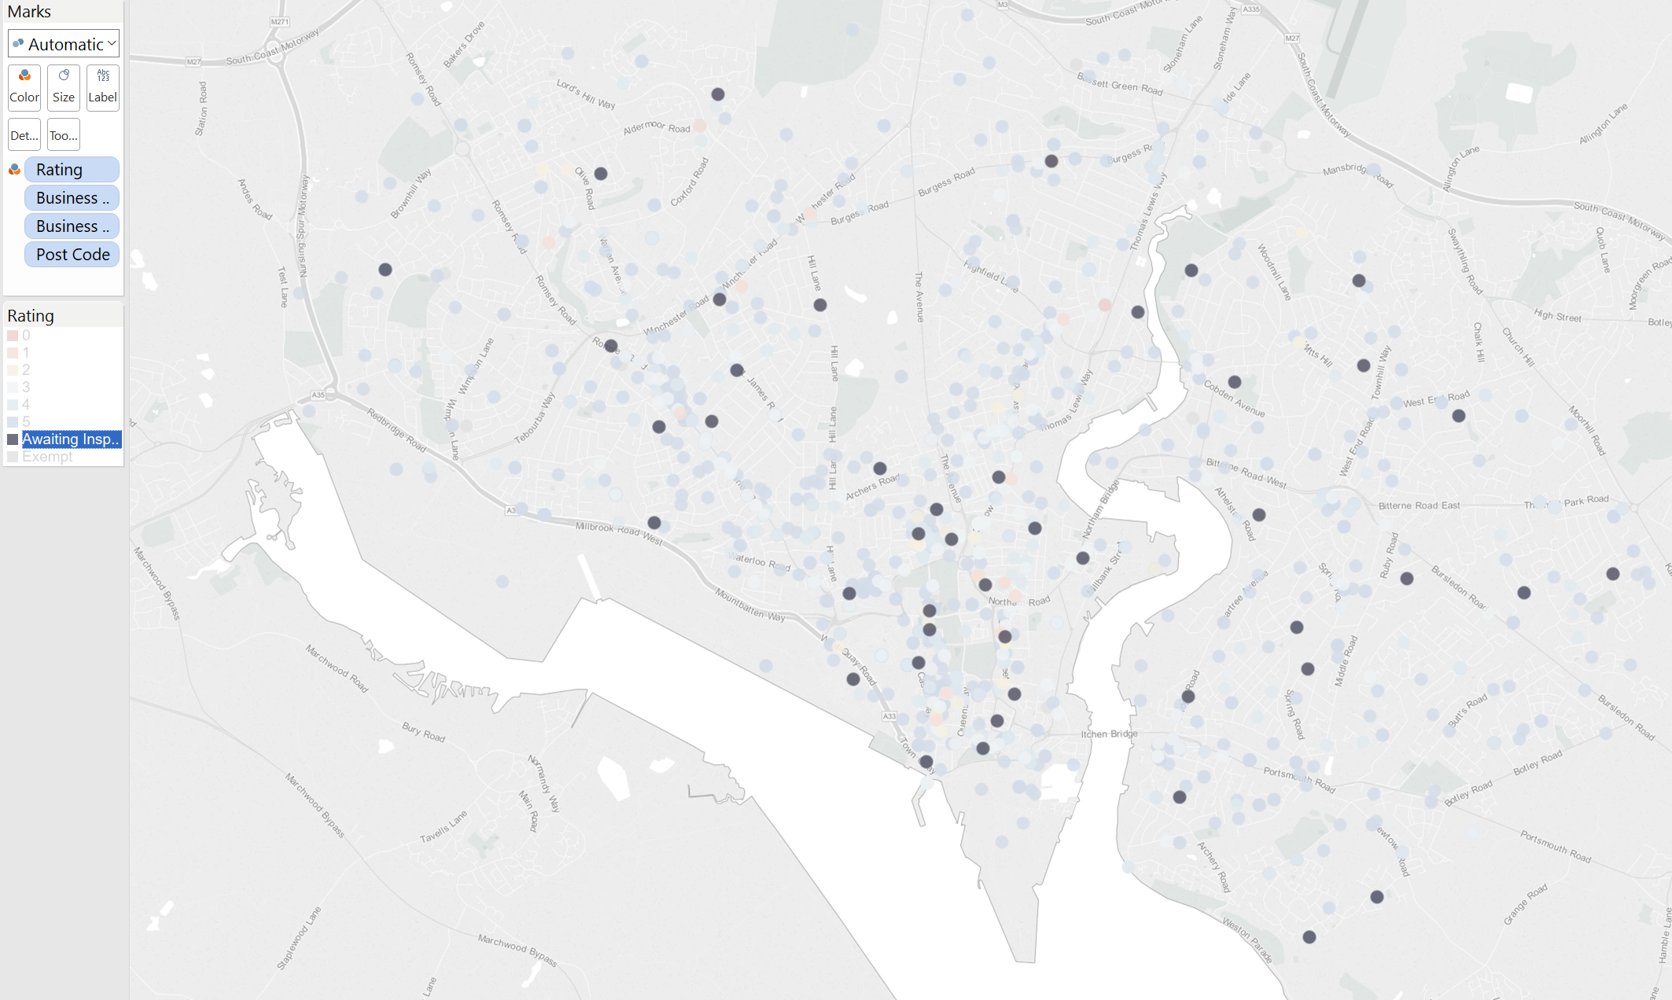

Figure 5: Using the filter on the Rating Value it is possible to visualize specific categories on the map.

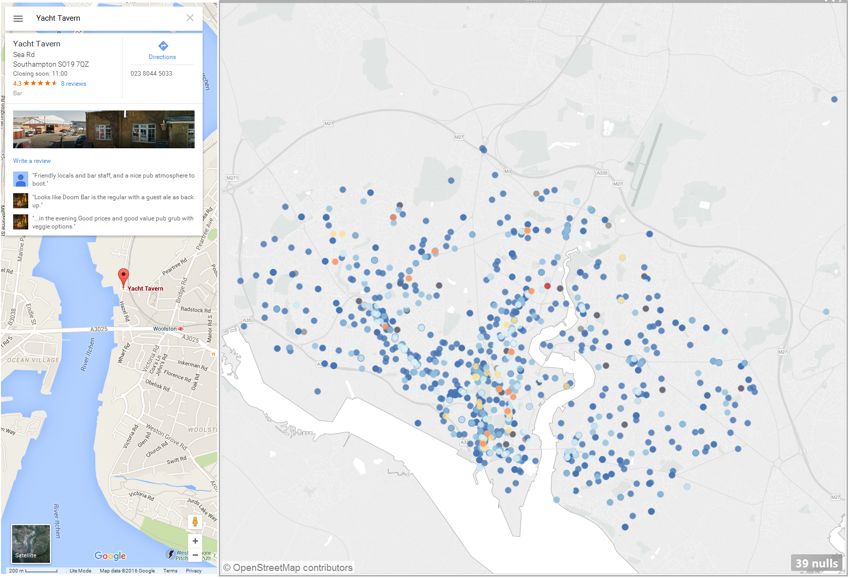

Figure 6: As specific point is selected, indications are visualized in the Google Maps window.



Figure 7: Google Maps is added as a URL action to the dashboard. Here we can see how the web query is formulatied: variable names are included in angled brackets.

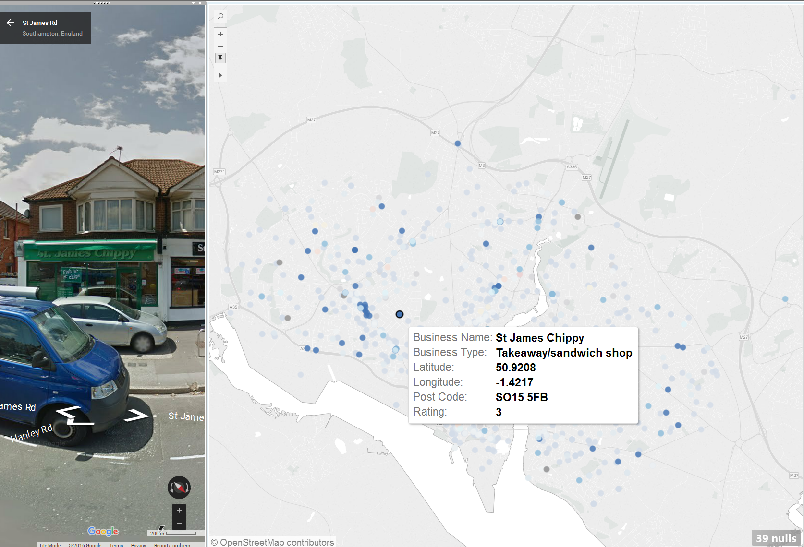

Figure 8: Example of the use of Google Maps Street View functionality. On the same Dashboard the user is easily able to visualize a real picture of the business.

# Ratings within each postcode

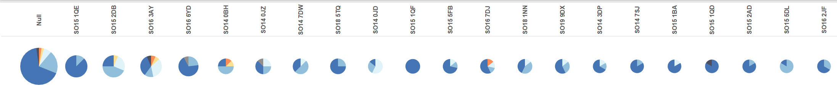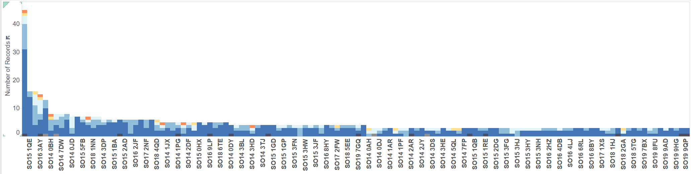 There are three main options of visualisation type: absolute value bar charts takes focus away from the distribution of the postcodes to the density of measurements. Pie charts do not scale well with the large number of postcodes that may be plotted so stacked bar chart is used, although it displays % distribution worse than pie charts and can’t easily encode absolute size values. To compensate absolute values are present on the tooltip and the postcodes are ordered by absolute size.

Figure 9 Both absolute number of records and percentage distribution (angle) for each postcode encoded in pie charts. Shows percentage distribution most clearly out of 3 options but doesn’t scale with large numbers of postcodes.

Figure 10 Absolute number of records per postcode as a barchart.

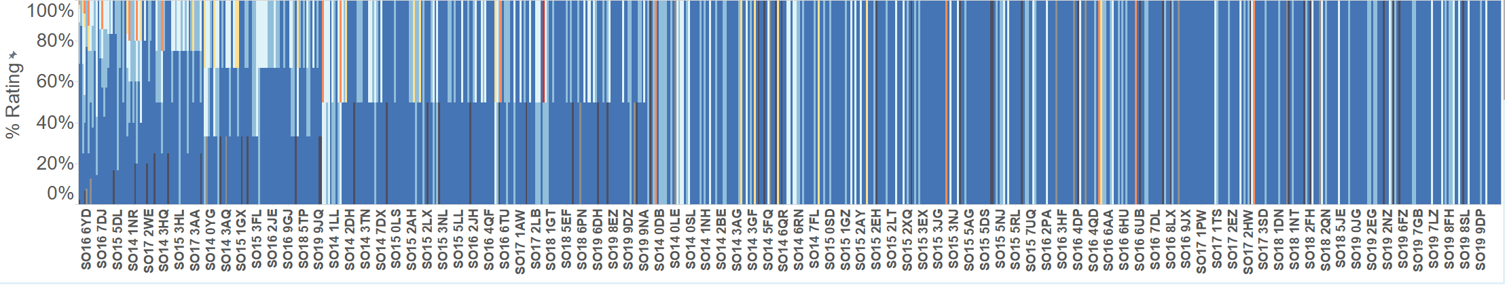

Figure 11 Absolute number of records per post code as a bar chart. Primary message of visualisation is distribution within postcodes, absolute value misdirects user focus away from this.

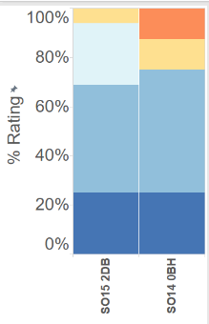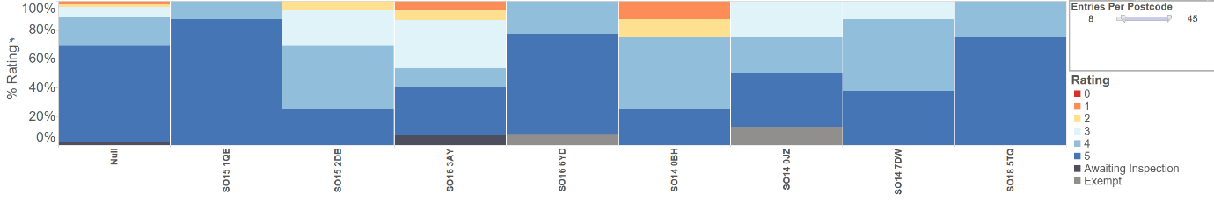

Figure 12 Percentage of postcode records encoded as a stacked bar chart, filtered by a minimum number of records (9). The inclusion of a minimum number of records filter makes the graph clearer by removing postcodes with statistically insignificant numbers of rec

Figure 13: SO15 1DB and SO14 0BH, the two postcodes with more than 8 entries and less than 50% 5 rating.

Figure 14 Percentage of postcode records encoded as a stacked bar chart. Keeps focus on distribution while allowing for (messy) inclusion of large numbers of postcodes

To clean Figure 14, a filter requiring a minimum number of records per postcode was made, by creating a calculated field of number of records per postcode and filter on it based on a parameter (to produce a slide bar). From here it is clear that SO15 1DB and SO14 0BH are the two postcodes with less than 50% rating 5 while having more than 8 records.

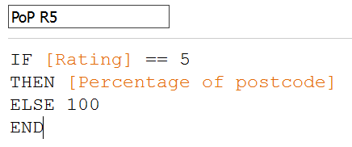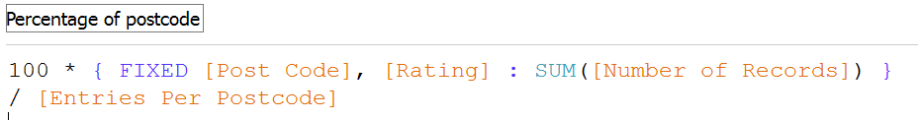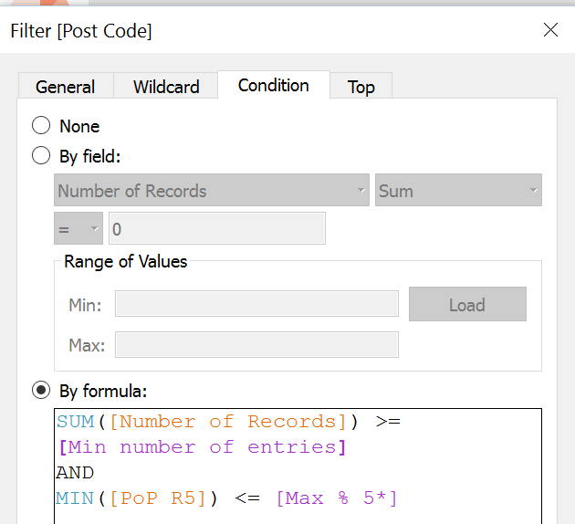

Figure 15 Postcodes with less than 50% 5 ratings can also be programmatically filtered by creating a percentage of postcode – rating 5 (PoP R5) calculated measure, via creating a percentage of postcode measure and filtering based on a minimum parameter of this value.

# Breakdown of Business Types

Like before percentage distribution is used rather than absolute values, because the focus is distribution within ratings and absolute values detract from that by focusing attention on more populated ratings, staying consistent between the two also helps avoid confusion. As before absolute values are shown as labels and on the tooltip.

A grouped bar chart was chosen because there are too many businesses to easily interpret a stacked bar chart and this allows for the most accurate visual comparison of business types within a star rating while also allowing comparison of star ratings across businesses. The chart was rotated horizontally because the business types are quite long and need to be read accurately.

Ideally zero recorded value business types would still be present, to clearly communicate a 0 and make distributions consistent but this feature is difficult to achieve in tableau with the “show empty rows” and “show missing values” not achieving this.

An action filter was included on the tooltip to allow users to view only one rating value and see that distribution more clearly. A selection highlighter was used so that on single select like businesses were highlighted, this allows the user to compare one business type’s distribution within a rating.

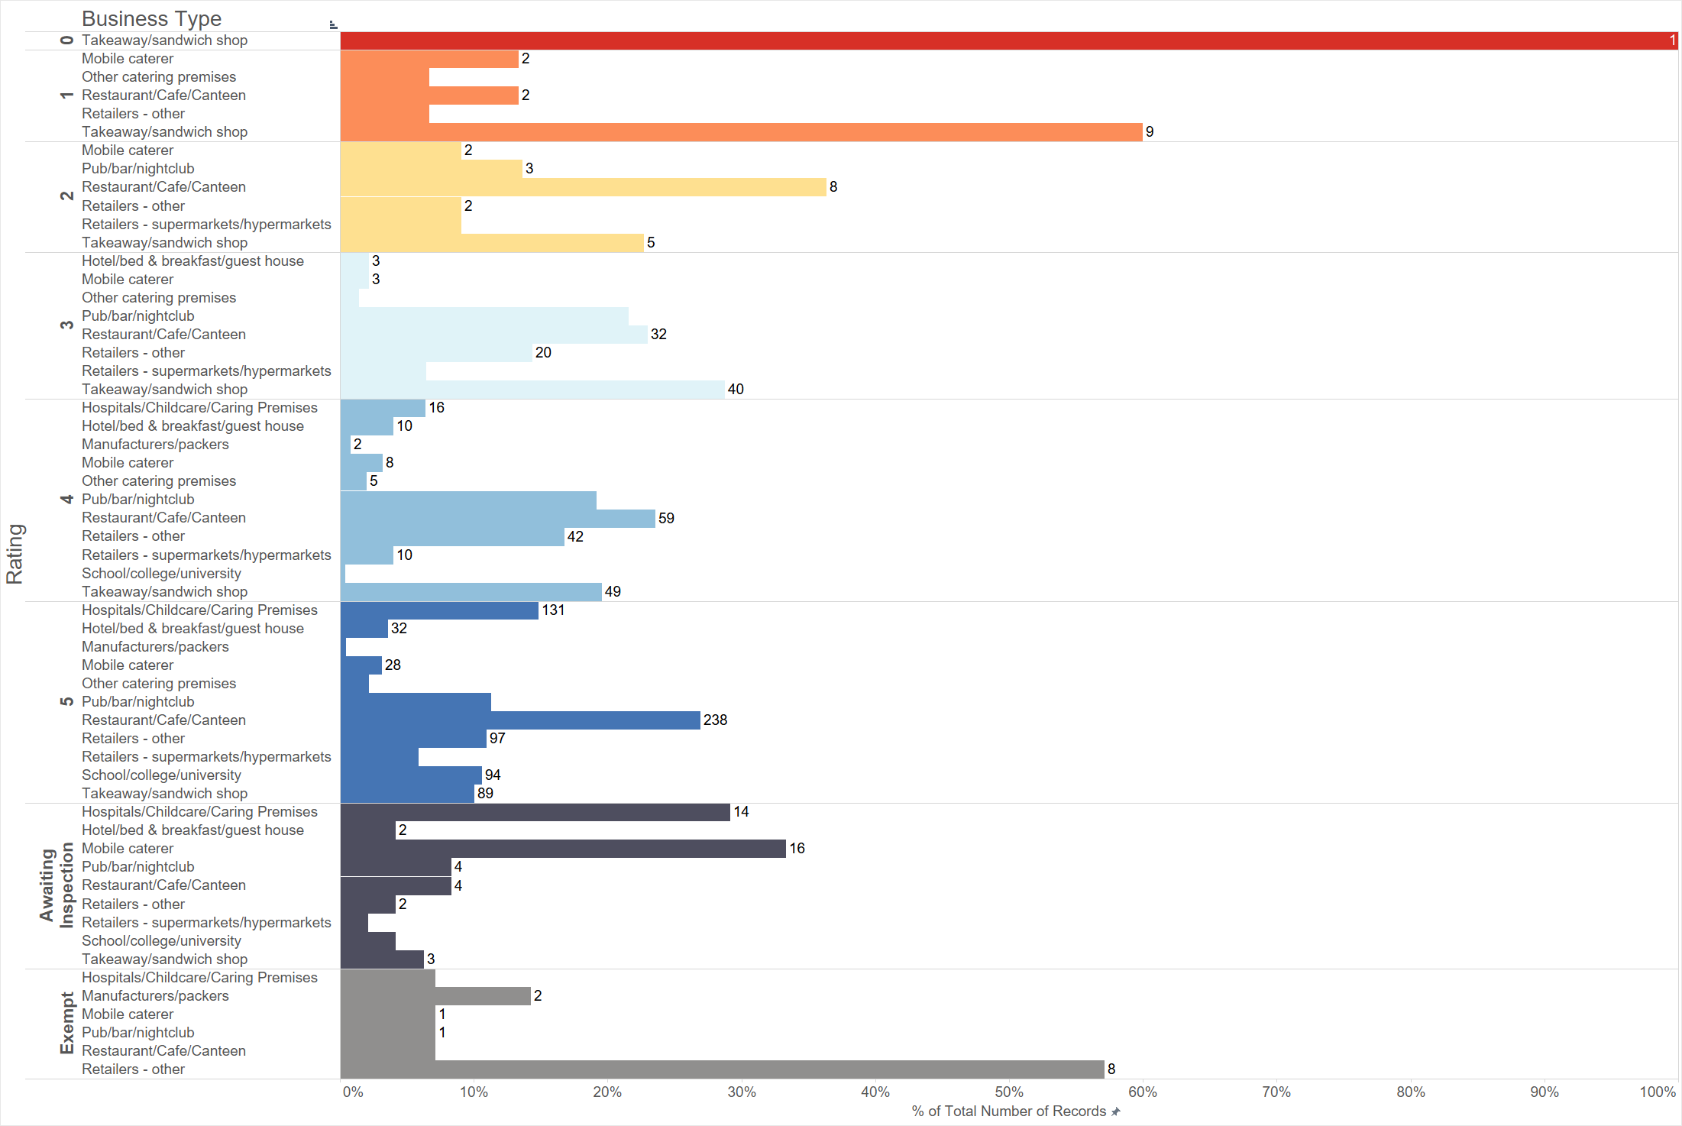

Figure 18: Horizontal grouped bar chart displaying the percentage breakdown of businesses within each rating. (Disclaimer, many of these screenshots are taken on a 4K screen, therefore they may appear especially zoomed out and text smaller). Colour was also used internal to the star ratings rather than across business types to keep a consistent colour scheme and to help keep the different ratings distributions visually separate on the graph, without it the internal percentage distributions may be confusing.

### 

Figure 16: Distribution of one business type across quality ratings highlighted by a single selection. Multi-selection doesn’t have this effect so custom highlighting and filtering isn’t restricted.

Figure 17: Distribution of businesses within one rating using the “Filter Quality” button. Ideally selecting rating on the left would achieve this but it conflicts with the business action highlighting.

## Dashboard

In designing the final dashboard, the main aim has been optimizing the space available, while driving the user through an intuitive interactions to a good understanding of the data.

The map is the centre of the drill-down narrative offering an overview of the data and setting the scene immediately due to its familiar physical representation. The map is placed in the centre and largest object to be the starting point for the viewer to understand and interact with the data visualization.

Using the map, it is possible select a specific business or a group. The other graphs change with the selection and the reader’s attention is switched to these parts exploring the data deeper. On the other hand, filtering happens in both ways so there are mechanisms to filter: business type, rating, postcode through intuitive selections.

